# Project: Summarizing and Analyzing Research Papers

**Learner Name**: shan Dandyan

**Learner Email**: [shaandandyan5@gmail.com](mailto:shaandandyan5@gmail.com)

* **Topic**: SOCIAL SCIENCE ( EFFECT OF SOCIAL MEDIA ON HEALTH)
* **Research Paper**: https://www.researchgate.net/profile/V-Krishna-Priya/publication/340779328_IMPACT_OF_SOCIAL_MEDIA_ON_MENTAL_HEALTH_OF_STUDENTS/links/5e9d856e299bf13079aa9558/IMPACT-OF-SOCIAL-MEDIA-ON-MENTAL-HEALTH-OF-STUDENTS.pdf

**Initial prompt :**

Summarize the main objective of the research paper in 100 words focus on primary reseaech quetions and most significant results

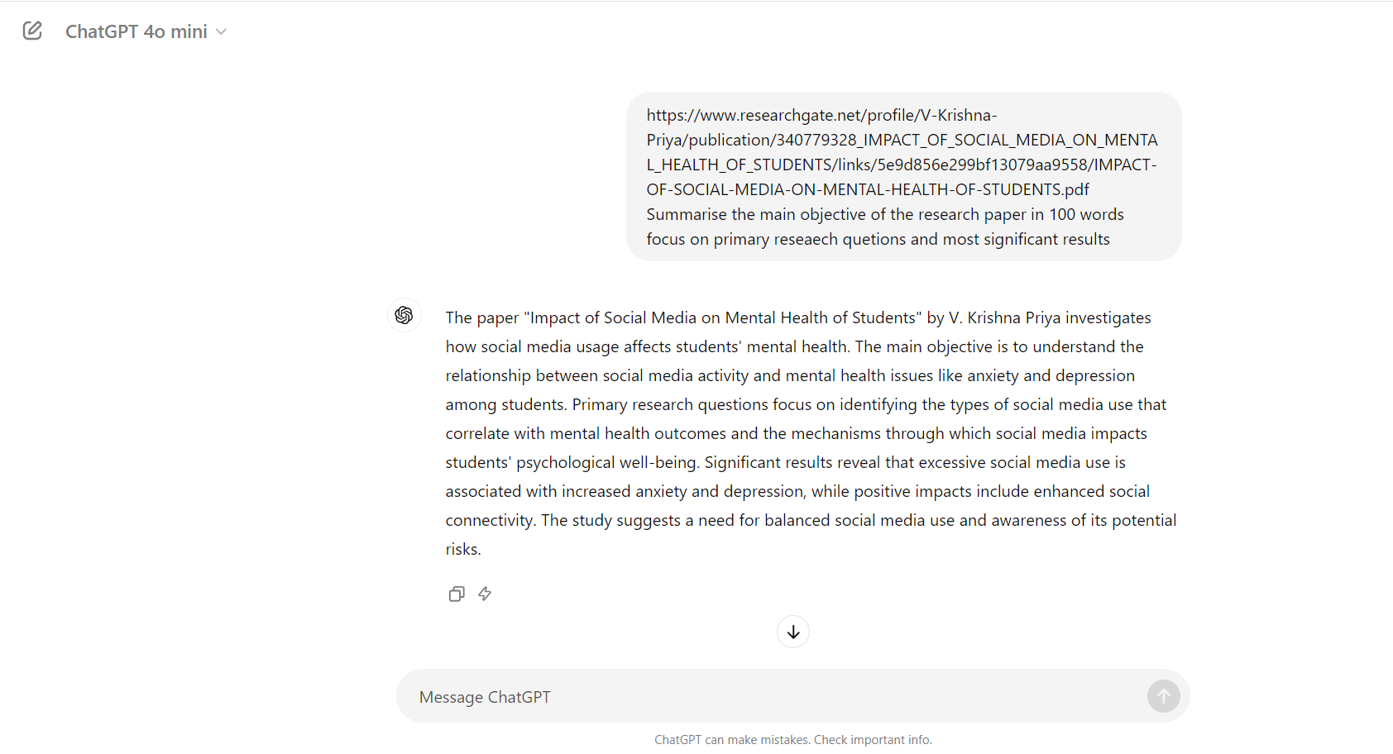

**Description:**

The initial prompt generates a general summary of the research paper within 100 words.

**Generated summary:**

The paper "Impact of Social Media on Mental Health of Students" by V. Krishna Priya investigates how social media usage affects students' mental health. The main objective is to understand the relationship between social media activity and mental health issues like anxiety and depression among students. Primary research questions focus on identifying the types of social media use that correlate with mental health outcomes and the mechanisms through which social media impacts students' psychological well-being. Significant results reveal that excessive social media use is associated with increased anxiety and depression, while positive impacts include enhanced social connectivity. The study suggests a need for balanced social media use and awareness of its potential risks.

**Iteration 1:**

**build on the intial summary by providing more details on the methodology or factor contributing to the effect in 150 words**

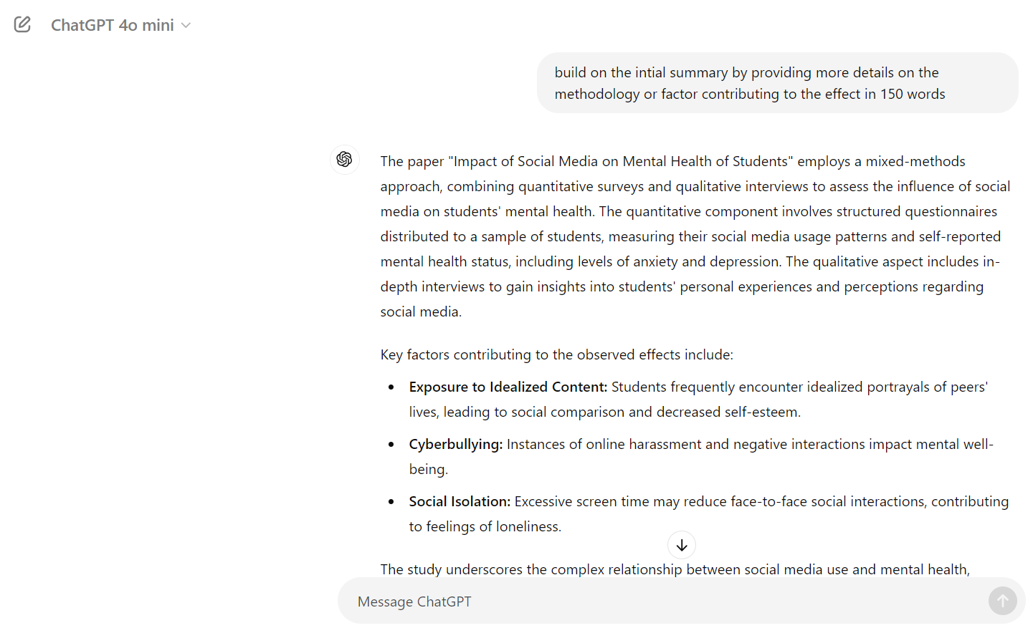

**Description:**

Expanded summary including methodology and factors contributing to the effect in 150 words.

**Generated summary:**

The paper "Impact of Social Media on Mental Health of Students" employs a mixed-methods approach, combining quantitative surveys and qualitative interviews to assess the influence of social media on students' mental health. The quantitative component involves structured questionnaires distributed to a sample of students, measuring their social media usage patterns and self-reported mental health status, including levels of anxiety and depression. The qualitative aspect includes in-depth interviews to gain insights into students' personal experiences and perceptions regarding social media.

Key factors contributing to the observed effects include:

- **Exposure to Idealized Content:** Students frequently encounter idealized portrayals of peers' lives, leading to social comparison and decreased self-esteem.

- **Cyberbullying:** Instances of online harassment and negative interactions impact mental well-being.

- **Social Isolation:** Excessive screen time may reduce face-to-face social interactions, contributing to feelings of loneliness.

The study underscores the complex relationship between social media use and mental health, advocating for strategies to manage social media consumption and enhance mental health resilience.

**Iteration 2:**

further elaborate on the expanded summary by discussing the implication of finding and any limitation of future research in 75 words

**Description:**

Comprehencive summary further elaborating on the implication of finding and any limitation of future research

**Generated summary:**

The findings imply that reducing social media usage and mitigating exposure to negative content could improve students' mental health, suggesting the need for educational and policy interventions. However, the study's limitations include its reliance on self-reported data, which may introduce bias, and its cross-sectional design, which prevents causal inferences. Future research should use longitudinal approaches and objective measures to further validate these findings and explore interventions for healthier social media practices.

**Final prompt:** condense the comprehensive summary in final 50 words that captures the research paper including its objective and border significance

**Description:**

Concise abstract that condense the comprehensive summary in final 50 words that captures the research paper including its objective and border significance

**Generated summary:**

The study explores how social media affects students' mental health, revealing that excessive use correlates with increased anxiety and depression. It highlights the impact of negative content and prolonged engagement. Future research should address self-report biases and use longitudinal designs to refine intervention strategies for healthier social media use.

**Key Findings:**

. The key findings of the research paper are:

1. **Increased Mental Health Issues**: Higher social media usage is significantly associated with elevated levels of anxiety and depression among students.

2. **Negative Content Exposure**: Frequent exposure to negative or distressing content on social media contributes to poorer mental health outcomes.

3. **Impact of Social Comparison**: Engaging in social comparison and experiencing cyberbullying are major factors worsening mental health.

4. **Time Spent on Social Media**: Prolonged use of social media is linked to greater mental health issues, emphasizing the need for managing usage.

**Overall Evaluation Summary:**

The research paper provides a comprehensive analysis of how social media affects students' mental health, revealing a significant link between extensive social media use and increased anxiety and depression. Key findings include the detrimental impact of negative content, social comparison, and cyberbullying. The study underscores the importance of managing social media usage to mitigate these adverse effects. While the results are insightful, the study’s reliance on self-reported data and its cross-sectional nature limit the ability to establish causality. Future research should address these limitations by employing longitudinal designs and objective measures to better understand and address the impact of social media on mental health.

窗体顶端

窗体底端

***Overall Relevance:**

The overall relevance of the research paper lies in its critical examination of the impact of social media on students' mental health, a pressing issue in today's digital age. By highlighting the significant associations between social media usage and mental health challenges such as anxiety and depression, the study provides valuable insights for educators, policymakers, and mental health professionals. The findings underscore the need for effective strategies to manage social media use and address negative content, making it highly pertinent for developing interventions aimed at improving student well-being and fostering healthier online environments.

**Overall Reflection:**

The research paper offers a crucial reflection on the modern intersection of social media and mental health, particularly within the student demographic. It highlights how pervasive social media use can exacerbate mental health issues, revealing the urgent need for awareness and proactive measures. The study’s focus on the negative effects of social comparison, cyberbullying, and content exposure emphasizes the complex nature of social media's impact. While the paper's insights are valuable, it also underscores the necessity for more nuanced, long-term research to deepen understanding and refine intervention strategies. Overall, it prompts a reconsideration of social media habits and the development of supportive frameworks to safeguard mental health in the digital age.